COMP330 Assignment 1 Report

**Name**: Connor Wilson

**Student ID**: 44946058

Features implemented in this assignment:

|  |  |  |
| --- | --- | --- |
| **Feature** | **Mark** | **Check if used** |
| Static 2D world Buildings, river, helipad | 20% | X |
| Moving helicopter with keyboard control | 20% | X |
| Helicopter with spinning tandem rotors | 20% | X |
| Rescuing people | 5% | X |
| Resizing the canvas, maintaining aspect ratio | 5% | X |
| Control helicopter with the mouse | 10% |  |
| Camera mounted on the helicopter | 10% |  |
| Minimap | 10% | X |
| Curved Rivers | 10% | X |
| Rain particle effect | 10% |  |
| Heads up display | 10% | X |
| **TOTAL** (max 100%) | 130% | 100% |

On the following pages you should indicate where each of the above features appear in your game, using screenshots and filenames/line-numbers to indicate where it occurs in your project.

You will not get marks for a feature if your marker cannot easily locate it within your world.

## Static 2D World

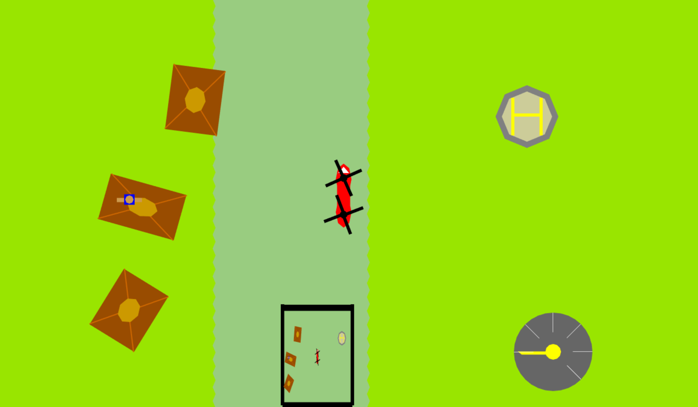

Implemented in:

* game.js:123-136 – initialization of the colours
* game.js:139-143 - initialization code for river
* game.js:145-178 – initialization code for house
* game.js:181-204 – initialization code for helipad
* the rectangle, triangle and circle are in Rectangle.js, Triangle.js and Circle.js respectively
* game.js:532-547 – Rendering the river
* game.js:550-552- Rendering the helipad
* game.js:557-567 – Rendering all the houses

## Moving and rendering the helicopter and Spinning tandem rotor blades

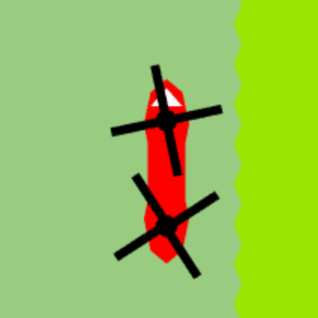

Implemented in:

* game.js:207-310 – initialization of the Helicopter
* input.js:15-30 and input.js:46-61 – initialization of the inputs
* game.js:559-561 – Render the helicopter
* game.js:479-505 – the control updates
* game.js:440-442 – the constant for the rotor blades

## Rescuing people

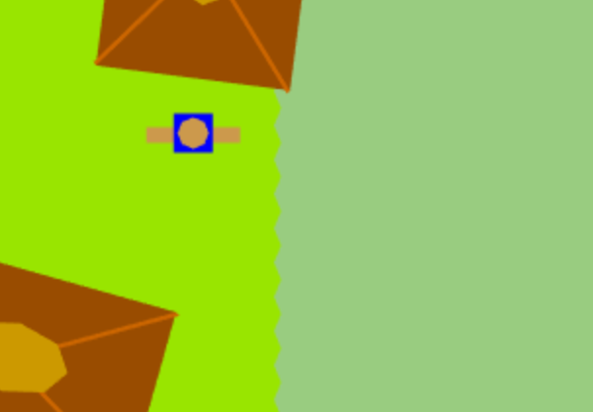

Implemented in:

* game.js:313-335 – initialization of people
* game.js:448-458 – code to pick up people
* game.js:446-477 – code to land and take off

## Aspect Ratio

Implemented in:

* game.js:515 – code to set the viewport
* style.css: - aspect ratio’s

## Minimap

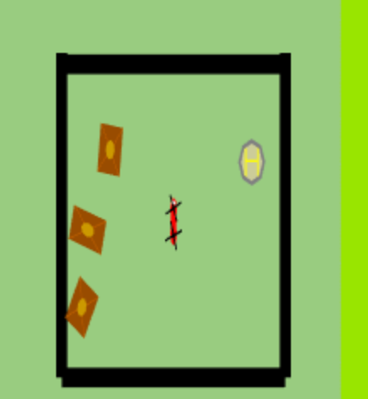

Implemented in:

* game.js:594-651 – sets the new viewport and re renders everything

## Curved River



Implemented in

* game.js:139-143 - initialization code for river
* game.js:440 – random number for animation
* game.js:537-548 – drawing the circles for animation

## Heads up display



Implemented in

* game.js:337-339 - initialization code for speedo
* game.js:496-507 –code controlling the movement
* game.js:581-583 – drawing the circles for animation